How to Submit a Determination Application
____________

Step 1: If you are a First Time OPRS Live User (https://oprslive.ovcr.uic.edu/), please register. Otherwise skip to Step 2:

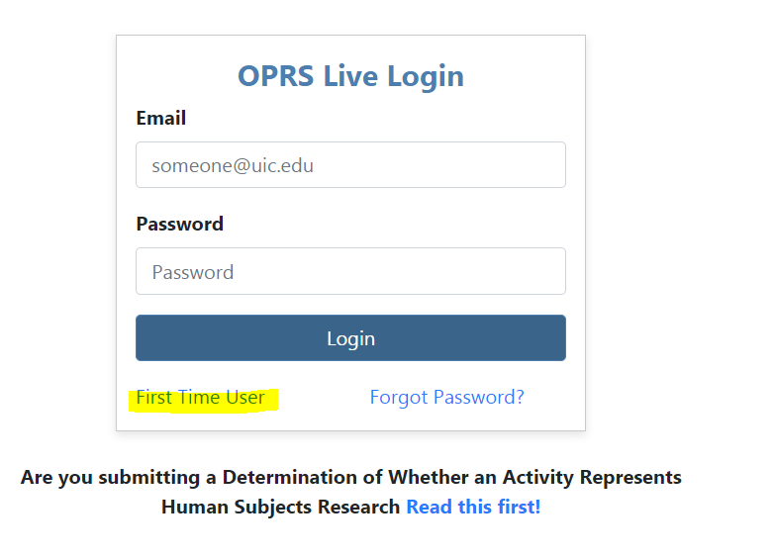
QUICK Tips:
- When registering, UIC faculty, staff and students MUST use their UIC Email address.
- If you do not have a UIC email address, please contact OPRS: uicirb@uic.edu or 312-996-1711
- You do not have to have UIC Investigator Training Record to submit a Determination application via OPRS Live.

Step 2: Read the instructions first!

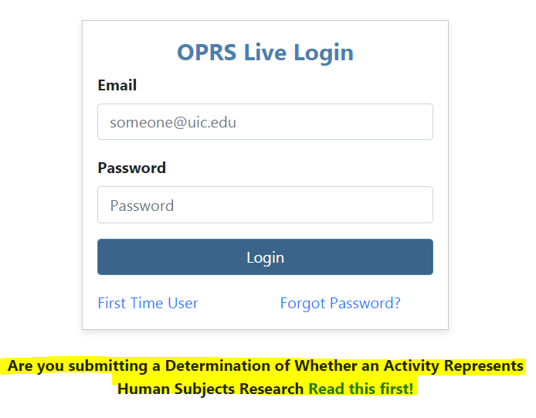
QUICK Tip:
- The primary purpose of this step is to remind investigators of the nine (9) specific activities that do not represent human subjects research and, therefore, do not require the submission of a Determination application.

Step 3: Login

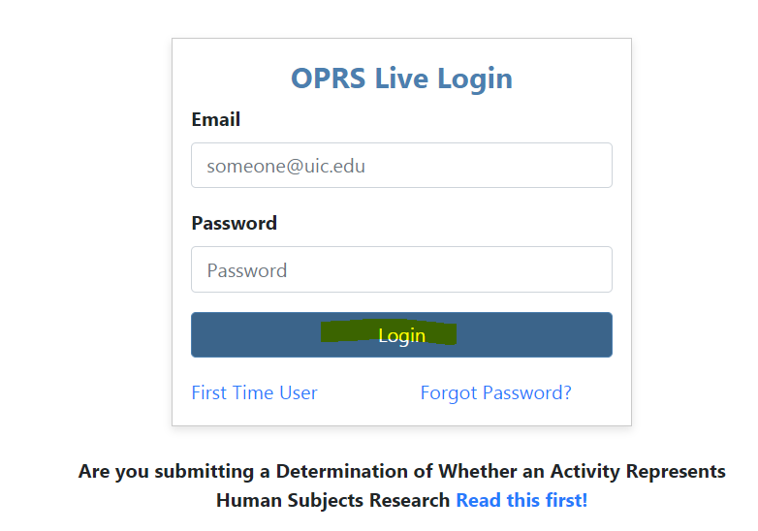

Step 4: In the Researcher Dashboard: Click “Start New Determination Application”:

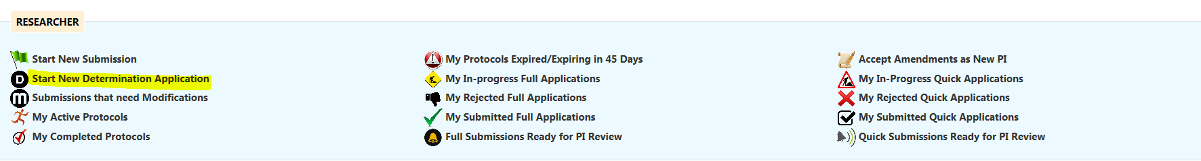

QUICK Tips:
- Please note that there is a dedicated button on the Researcher Dashboard for submitting Determination applications.
- IMPORTANT: To avoid unnecessary delays in the processing and/or review of your submissions, please DO NOT submit any other submission types (e.g., Initial Review Applications, Claim of Exemption application) utilizing the “Start New Determination Application” button.

Step 5: Complete Quick Submission (Step One):

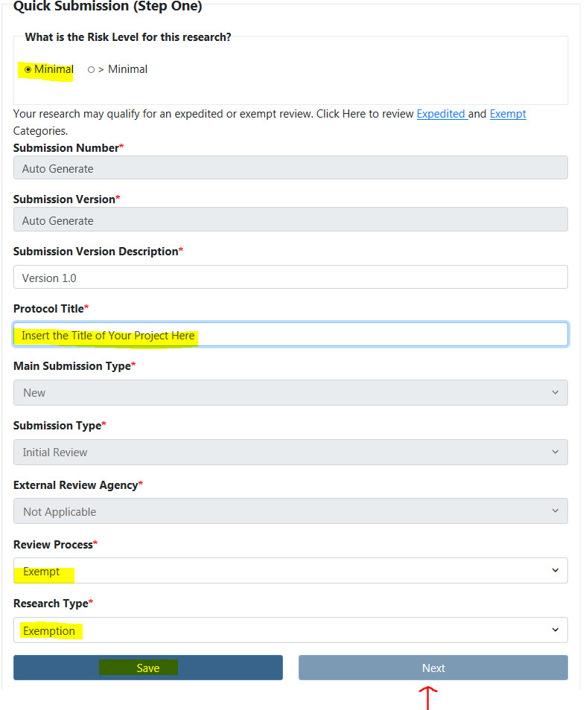
QUICK Tips:
- The purpose of Quick Submission (Step One) is to direct your Determination application to the appropriate review panel.

Step 6: Complete Quick Submission (Step Two):

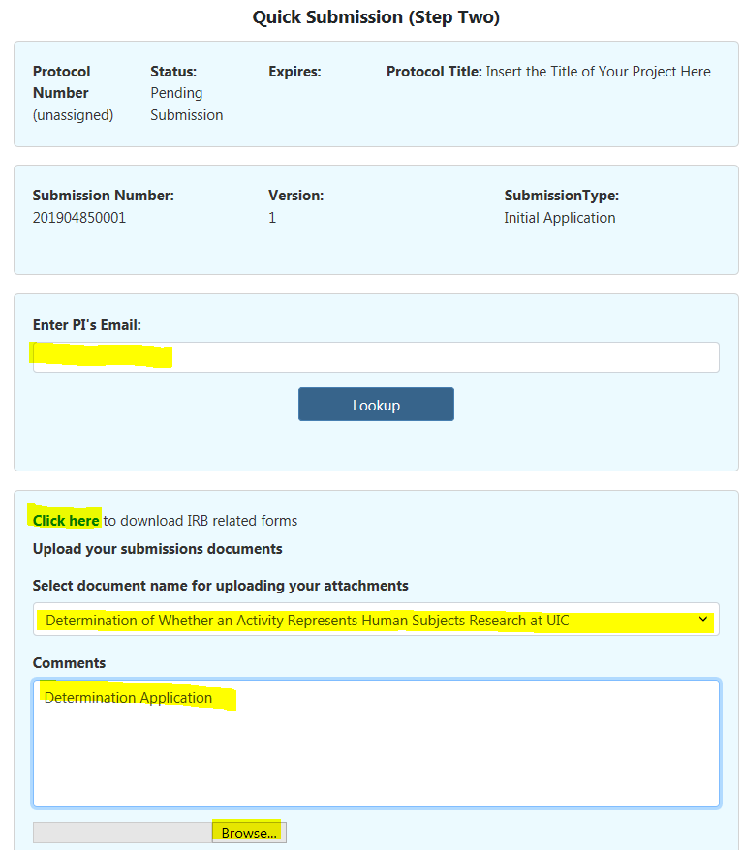
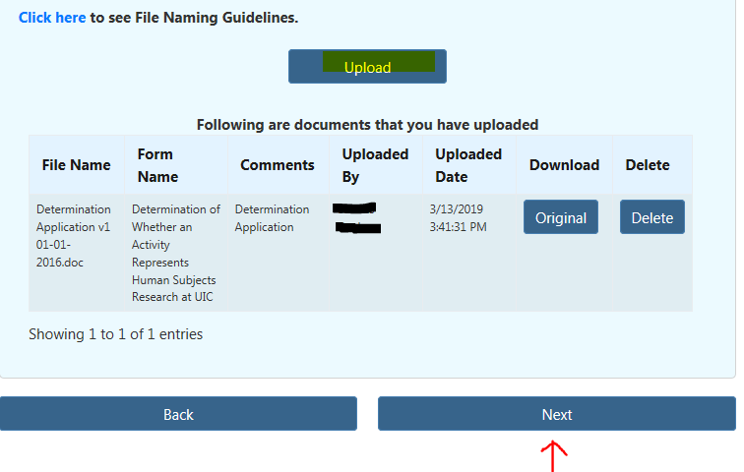

Step 7: Complete Quick Submission (Step Four):

